Objective: Identify and use the correct hand signals when working under noisy conditions.

Trainer’s Note

The American Society of Agricultural Engineers has adopted 11 uniform hand signals for safety. All workers, including delivery drivers and other workers who are at the job site, should learn the 11 signals and use them. That way, everyone will communicate in the same “language.” For this module:

• Demonstrate the signals in your tailgate presentation.
• Have someone else discuss how to perform the signal while you demonstrate the hand signal.
• Have workers practice them.
• You could post the hand signals in the coffee room or near a water fountain. This will allow
employees to see the signals every day.
• Review the important points.
• Have workers take the True/False quiz to check their learning.

Background

Hand signals are ideal for communication around noise. Hand signals provide a way to communicate needed information effectively in a noisy environment. All workers should learn and use these signals.

Why Use Hand Signals?

- Hand signals save time.
- Hand signals prevent accidents.
- Hand signals reduce severity of injuries.
- Hand signals lower the risk of accidental death.
- Hand signals communicate well in noisy environments.

The American Society of Agricultural Engineers (ASAE) has adopted 11 uniform hand signals for safety. The signals help workers communicate in the same “language.” The chart on the next page shows the 11 signals. With each hand signal there are detailed instructions for performing the signal.

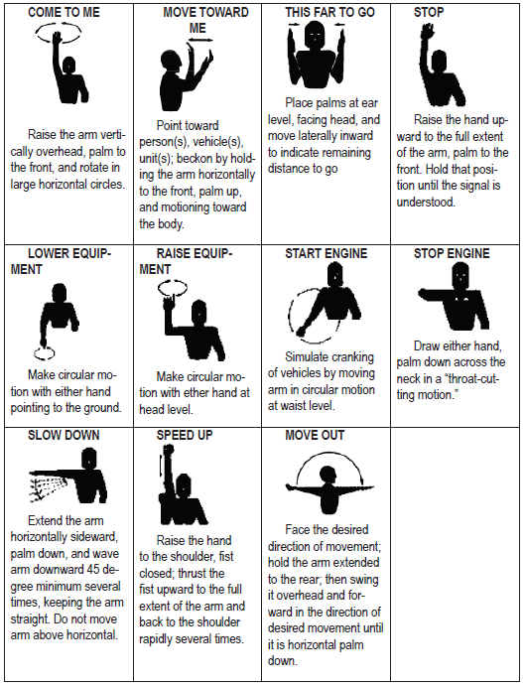

Review These Important Points

- Hand signals are an ideal communication tool for noisy situations.
- There are 11 ASAE uniform hand signals.
- Hand signals help save time and prevent accidents.
- Using hand signals could save a life.
- Review each signal with employees.

Verbal Quiz

1. To signal to stop, you should raise your hand upward to the full extent of the arm, T F
palm to the front.
2. Only the owner needs to know the hand signals. T F
3. There are 11 uniform ASAE hand signals. T F
4. Using the standard hand signals can save time and prevent accidents. T F
5. To indicate that the equipment needs to be lowered, make a circular motion with T F
either hand pointing to the ground.

Answer Key
1 | T
2 | F
3 | T
4 | T
5 | T

