SAVE MONEY WITH ONSITE DRUG TESTING KITS!

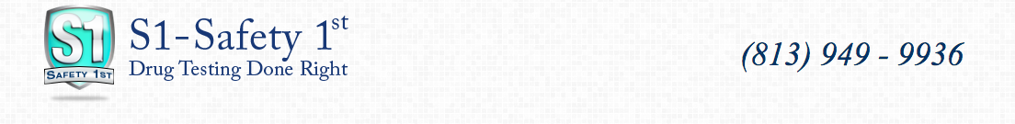

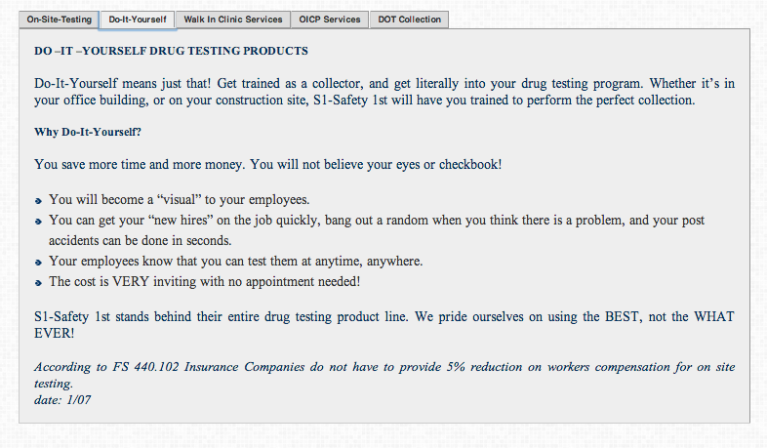

Contact Scott Ashdown at 407. 952.1045 to order your kits and start saving money now!

For additional Information, you can email Scott at : [scott@s1team.com](mailto:scott@s1team.com)

Please be sure to tell him Closson Insurance sent you. We get no money or personal gain from our referral – we just like people to know you’re our customer and give you excellent service.