Objective: Avoid contact with poison ivy, poison oak, and poison sumac and treat reactions to these poisonous plants.

Trainer’s Note
Poison ivy, poison oak, and poison sumac can cause a nasty reaction.
● Review the information below on how to identify these plants, avoid them, and treat a reaction.
● Ask workers where they have found poisonous plants while working.
● Review the important points.
● Have workers take the True/False quiz to check their learning.

Background
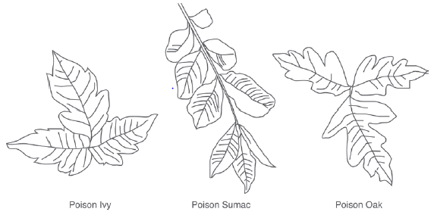
Many people are sensitive to poison ivy, poison oak, and poison sumac. A chemical called urushiol is present in the sap of these plants. If you touch or brush against a plant with broken stems or torn leaves, the sap can come into contact with your skin. The sap can cause a rash, blisters, and itching. Urushiol can stay on clothing, gloves, and tools for years if they are not washed.

How to Avoid Contact with Poison Ivy, Poison Oak, and Poison Sumac

- Recognize the leaf pattern of these poisonous plants and avoid them if possible.
- Try not to touch or brush against these plants.
- Dress appropriately. Wear gloves, a cap, a long-sleeve shirt, and long pants. Wear boots or shoes. Do not wear sandals or open-toed shoes.
- At the end of the workday, do not take a bath. Urushiol can stay in the tub water and can cling to your body when you get out of the tub. Instead, take a shower.
- Wash all your work clothes and gloves in hot water. Do not wash them with other clothes.
- Wash off tools with an outdoor water hose.
- Do not burn the plant. Burning can release the chemical in the smoke, and it can come into contact with your skin that way.

How to Treat a Poisonous Reaction

- If you know you have been exposed to urushiol, use rubbing alcohol on the exposed skin immediately. Once urushiol comes in contact with your skin, it penetrates very quickly. Also, do not return to the area where you were exposed until the next day. Rubbing alcohol removes the protective barrier on your skin and if you should contact urushiol again, it will penetrate your skin even faster.
- After using the rubbing alcohol, wash the exposed area with water.
- As soon as possible, shower with warm water and soap or a special wash like ZanfelTM.
- All clothing should be washed separately in hot water. Shoes should be wiped with rubbing alcohol and water. Wear disposable gloves while cleaning your shoes.

If a Rash, Blisters, or Itching Develops

- A rash or blisters may develop if the skin is not cleaned quickly. This redness or swelling usually occurs within 12 to 48 hours after contact.
- Oozing blisters are not contagious because they do not contain urushiol. The fluid cannot spread the rash to other parts of the body. However, do not rub or scratch the blisters or rash. Infection could occur if your hands or fingernails are dirty.
- You will only have a rash or blisters where urushiol touched your body. The rash will not spread by itself. However, you might get a rash in a new area if you handle contaminated items again.
- The rash and blisters may appear at different times because the poison may absorb into your skin at different rates of penetration, depending on what part of the body was exposed.
- If you do nothing, the rash, blisters, and itch will go away in two to three weeks.
- If you want to treat the rash, blisters, and itch, try putting wet compresses on the area or soaking in cool water.
- To ease the itching, you can take oral antihistamines or hydrocortisones. These pills can be purchased at a local pharmacy.
- If you have a severe reaction, see a doctor. The doctor may prescribe an oral corticosteroid especially if the rash is on a sensitive part of the body. The drug must be taken for at least two to three weeks. If you stop too soon, the rash can reappear and be even worse.
- These over-the-counter products may also help dry oozing blisters: aluminum acetate, baking soda, Aveeno, aluminum hydroxide gel, calamine, kaolin, zinc acetate, zinc carbonate, and zinc oxide. Follow the directions on the label.

Review These Important Points

- While you are working, try not to touch poisonous plants.
- Usushiol can remain on your clothes for years if they are not washed properly.
- When working around poisonous plants, wear clothing that covers as much of your body as possible.
- Do not burn poisonous plants. Burning can release the poison into the air.
- Use rubbing alcohol immediately if you come into contact with a poisonous plant.
- Shower with warm water and soap as soon as possible.
- Wash your clothes separately in hot water. Clean your shoes with alcohol and water.
- If you develop a rash, blisters, and itching, apply warm compresses to the infected areas or bathe in cool water.
- Try using over-the-counter products to help ease the itch. Follow the directions on the label.
- If you have a severe reaction, see a doctor.

Verbal Quiz

1. A warm bath is a good way to get urushiol off your skin. T F
2. The poison urushiol can stay on your clothes for years if clothes are not washed. T F
3. Burning poisonous plants destroys the urushiol. T F
4. Rubbing alcohol can be used to clean skin that has come into contact with a poisonous plant. T F
5. Once urushiol touches your body, it can spread to other parts. T F
Agricultural Safety Program, 590 Woody Hayes Drive, Columbus, OH

Answer Key
1 | F
2 | T
3 | F
4 | T
5 | F

